Deep learning Ex1

Ariel Radomislensky 211991146

Question 1

$$softmax_{\left[i\right]}\left(z+m⋅1\right)=\frac{exp⁡(z_{i}+m)}{\sum_{j}{\exp\left(z_{j}+m\right)}}=\frac{\exp\left(z_{i}\right)\exp\left(m\right)}{\exp\left(m\right)\sum_{j}{\exp\left(z_{j}\right)}}=\frac{\exp\left(z_{i}\right)}{\sum_{j}{\exp\left(z_{j}\right)}}=softmax_{\left[i\right]}(z)$$

1. for $c=2$: $$z=\left[\begin{matrix}z_{0} \\ z_{1}\end{matrix}\right], softmax_{\left[0\right]}\left(z\right)=\frac{\exp\left(z_{0}\right)}{\exp\left(z_{0}\right)+\exp\left(z_{1}\right)}=\frac{1}{1+\exp\left(z_{1}-z_{0}\right)}=σ\left(z_{0}-z_{1}\right) \\ softmax_{\left[1\right]}\left(z\right)=\frac{\exp\left(z_{1}\right)}{\exp\left(z_{0}\right)+\exp\left(z_{1}\right)}=\frac{1}{1+\exp\left(z_{0}-z_{1}\right)}=σ\left(z_{1}-z_{0}\right)$$

$$f\left(z\right)=\frac{1}{π}\arctan\left(z\right)+\frac{1}{2}$$

Question 3

1. $$U=\left[\begin{matrix}1 & -1 \\ -1 & 1\end{matrix}\right], b_{1}=-0.5, w=1, b_{2}=-0.5$$ verified using python:

For x = [0 0] hidden layer output is [0. 0.]

For x = [0 0] output is 0

For x = [0 1] hidden layer output is [0. 0.5]

For x = [0 1] output is 1

For x = [1 0] hidden layer output is [0.5 0. ]

For x = [1 0] output is 1

For x = [1 1] hidden layer output is [0. 0.]

For x = [1 1] output is 0

import numpy as np

U = np.array([[1,-1],[-1,1]])

b1 = -0.5

w = np.array([1,1]).T

b2 = -0.1

X = [np.array([0,0]).T, np.array([0,1]).T, np.array([1,0]).T, np.array([1,1]).T]

for x in X:

h = np.maximum(U.T@x + b1, np.zeros((2,)))

print("For x = ", x, "hidden layer output is ", h)

f = w.T@h + b2

if(f>=0):

print("For x = ", x, "output is 1")

else:

print("For x = ", x, "output is 0")

1. No, it would not be possible, replacing the max function with the identity will effectively eliminate the hidden layer: $$f\left(x\right)=w^{T}\left(U^{T}x+b_{1}\right)+b_{2}=w^{T}U^{T}x+w^{T}b_{1}+b_{2} \\ w^{'}=Uw, b^{'}=w^{T}b_{1}+b_{2} \\ ⇓ \\ f\left(x\right)=w^{'T}x+b^{'}$$ 
   turning $f$ into a linear classifier, and XOR cannot be linearly classified.
2. ReLU(x) can in fact be defined as max(x,0). Maybe the question meant weather we can set $b_{1}=0$? If so yes, it is still possible:

For x = [0 0] hidden layer output is [0. 0.]

For x = [0 0] output is 0

For x = [0 1] hidden layer output is [1. 0.]

For x = [0 1] output is 1

For x = [1 0] hidden layer output is [0. 1.]

For x = [1 0] output is 1

For x = [1 1] hidden layer output is [0. 0.]

For x = [1 1] output is 0

import numpy as np

U = np.array([[1,-1],[-1,1]])

b1 = 0

w = np.array([1,1]).T

b2 = -0.1

X = [np.array([0,0]).T, np.array([0,1]).T, np.array([1,0]).T, np.array([1,1]).T]

for x in X:

h = np.maximum(U.T@x + b1, np.zeros((2,)))

print("For x = ", x, "hidden layer output is ", h)

f = w.T@h + b2

if(f>=0):

print("For x = ", x, "output is 1")

else:

print("For x = ", x, "output is 0")

Question 3

To use backward propagation, we need to calculate the gradients:

$$L={\left(y-\hat{y}\right)}^{2} \\ \hat{y}=f\left(x\right)=w^{T}h+b_{2}=w_{1}h_{1}+w_{2}h_{2}+b_{2} \\ h=ReLU\left(U^{T}x+b_{1}\right)=ReLU\left(z\right)⇒h^{'}\left(z\right)=U(z) \\ z=U^{T}x+b_{1}=\left[\begin{matrix}U_{1,1}x_{1}+U_{2,1}x_{2}+b_{1,1} \\ U_{1,2}x_{1}+U_{2,2}x_{2}+b_{1,2}\end{matrix}\right]$$

$$\frac{∂L}{∂w_{i}}=\frac{∂L}{∂\hat{y}}\frac{∂\hat{y}}{∂w}=-2\left(y-\hat{y}\right)h_{i} \\ \frac{∂L}{∂b_{2}}=\frac{∂L}{∂\hat{y}}\frac{∂\hat{y}}{∂b_{2}}=-2\left(y-\hat{y}\right) \\ \frac{∂L}{∂U_{ij}}=\frac{∂L}{∂\hat{y}}\frac{∂\hat{y}}{∂h_{j}}\frac{∂h_{j}}{∂z_{j}}\frac{∂z_{j}}{∂U_{ij}}= -2\left(y-\hat{y}\right) w_{j}U\left(z_{j }\right) x_{i} \\ \frac{∂L}{∂b_{1,i}}=\frac{∂L}{∂\hat{y}}\frac{∂\hat{y}}{∂h_{i}}\frac{∂h}{∂z_{i}}\frac{∂z_{i}}{∂b_{1,i}}=-2\left(y-\hat{y}\right) w_{i} U\left(z_{i}\right)$$

And implement in the code.

The code uses pandas for visualization, it can be easily installed via `pip install pandas`

To run the code, open a terminal window, cd into the directory where you stored the script, and run it with `python3 Q3.py`, the code will generate 5 png files.

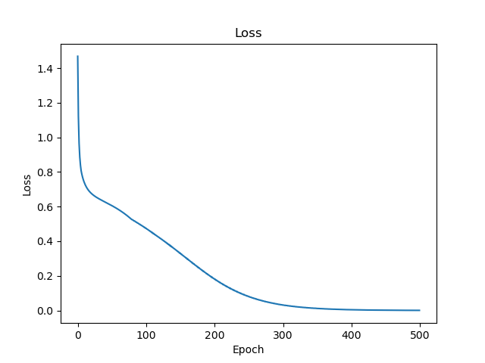Here are the plots from my run with 500 epochs:

Challenges:

Initially I tried creating the weights and biases history by simply appending the numpy array to a list, I was surprised to see that the result was the same number. My mistake was appending the actual array which is static in memory instead of a copy of it.

Going from calculus to python code was challenging, I ended taking a matlab approach of representing everything as a matrix.